LINUX basic commands

1 $/ shows root directory
2 /~ is current home directory
3. pwd shows the directory which we are in
4. ls shows list of files
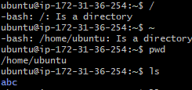
5. mkdir tech123 created new file
6. ls tech123 is listed in files
7. mv tech123 .tech123 gave this command to hide the file and when searched for command /ls file tech123 did not show-up in the list of files
8. mv .tech123 tech123 gave this command to unhide the file, when searched for tech123 in list of files by giving command /ls was able to find it in the list.
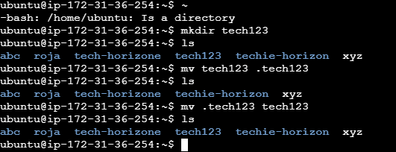

9. touch abc gave this command to create a file with 0 size
10. vi abc.txt , used this command to open VI editor. Once the editor is opened changed it to insert mode and written the text. To save this file clicked esc repeatedly for 3 to 4 times and typed :wq! To save and exit the editor file.
11. cat abc.txt, used this command to read the file content and so it gave the output as follows.
12. wc abc, given this command to count the words and hence there is no content in this file, it gave output as 0. Also given the command to wc abc.txt to read the words in this file, it gave output

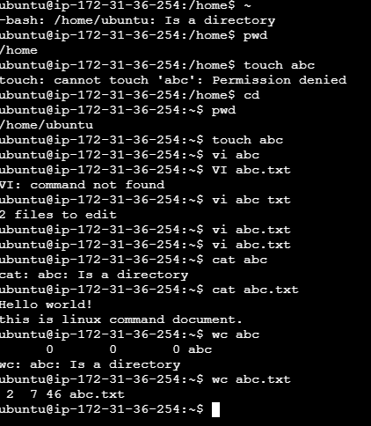

13. ll , for this command it gave output as total 64 and listed those files with their details.
14. rm –rf tech123, with this command was able to delete the tech123 file. Also when checked in list of files, this was not listed.
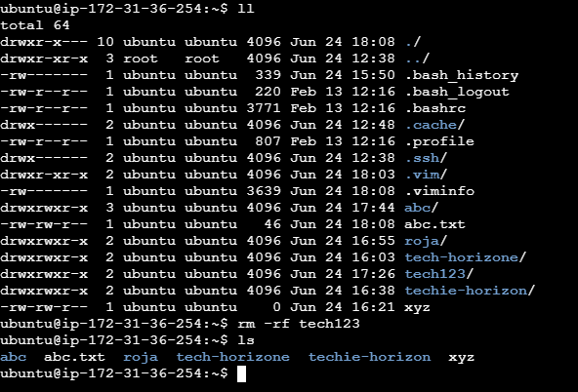

15. ls -ltr, used this command to obtain list of files according to time and below is the output
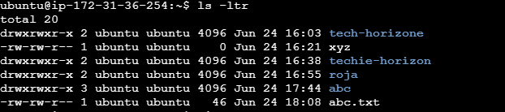

16.history and obtained the below output.

